PYGAME ASSESSMENT
Test Plan
I am going to testing the game by using the acceptance testing method. Acceptance testing is when you test the game using the user requirement to make sure that the game meets the client requirements. I would be testing the non-functional requirements as it is important that it satisfies the client so that the program can be delivered and the client would be happy.

Test Strategies
White Box Testing
I will be the white box tester meaning that I would go through the code that I have built to make sure the game meet the requirements and debug any errors.
Unit Testing
I will go through one small part at a time in the game to make sure every small bit is error free.
System Testing
After I have done the unit testing, I will test the game fully as if I am the user to make sure that the game runs smoothly and it is ready to be delivered.
Acceptance Testing
Numbers | Requirements | Result | Status
1 | Should contain 5 levels. | 5 levels contained.  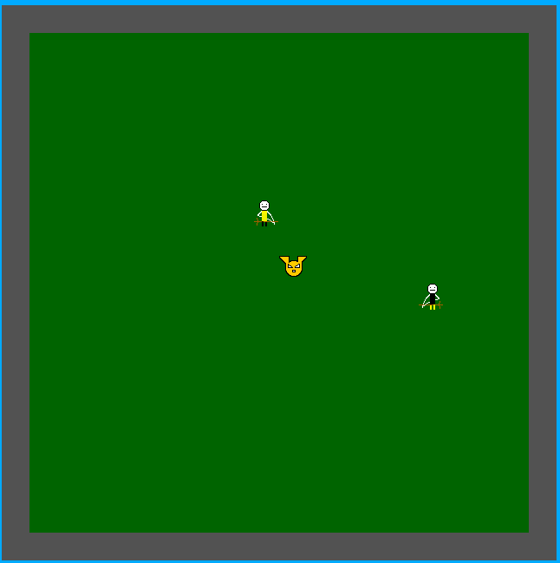  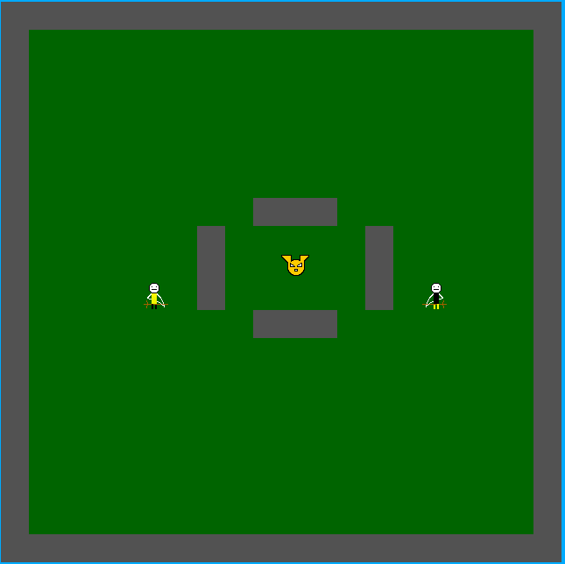  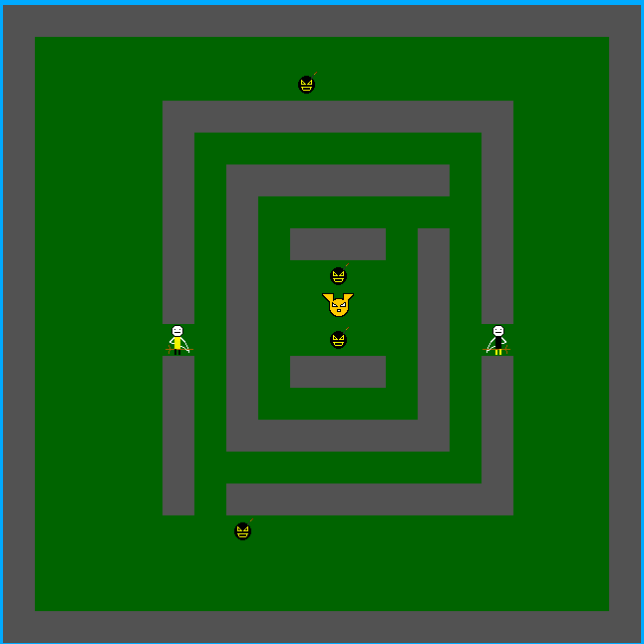  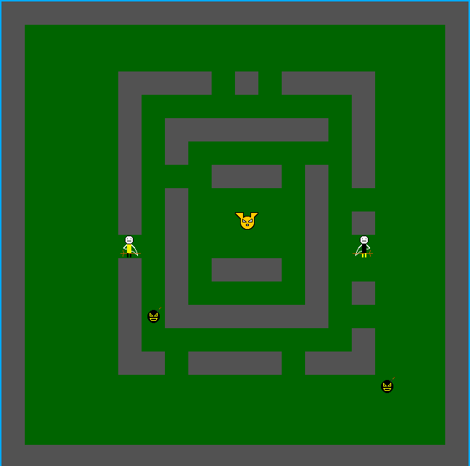  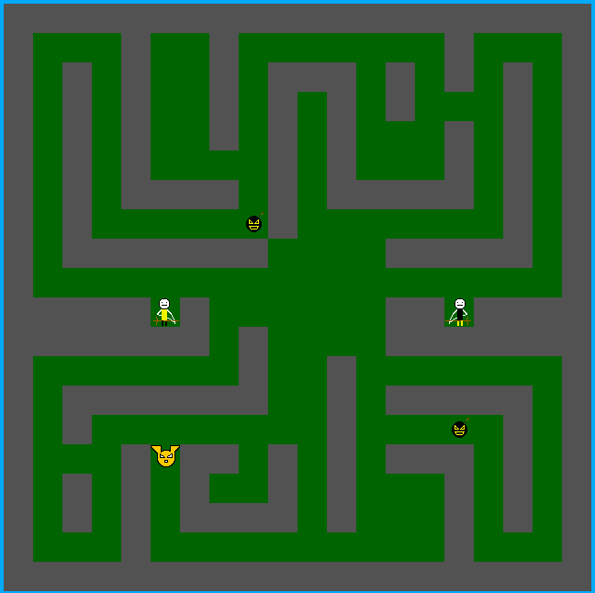 | Pass
2 | Should be a 2 player game | 2 player game  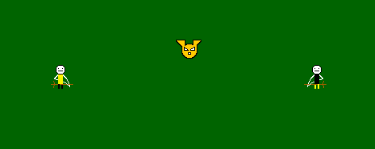 | Pass
3 | Player should proceed to the next level if they catch the snitch | Takes player to next level if the snitch is caught  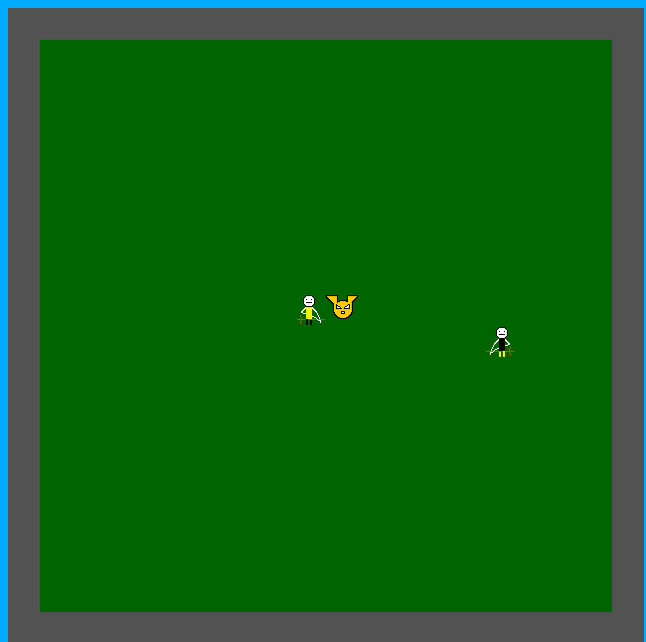  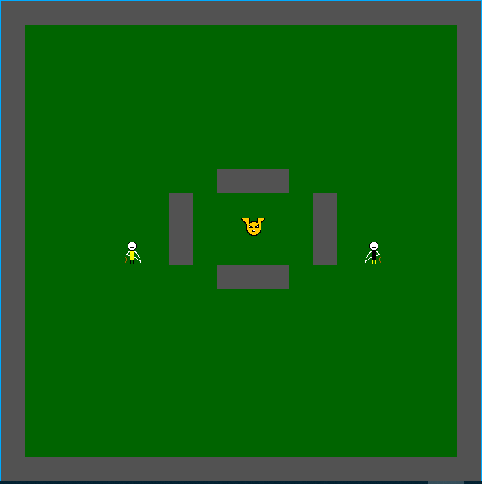 | Pass
4 | Program should record the number of moves to complete game | Displays number of moves to complete a game.  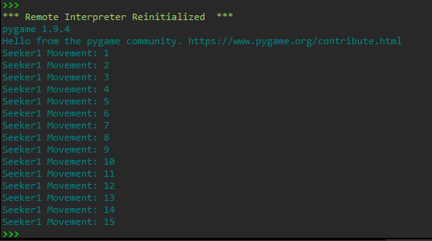 | Pass
5 | Level one should be simple with 2 seekers and frozen snitch | Level One is simple with 2 seekers and a frozen snitch  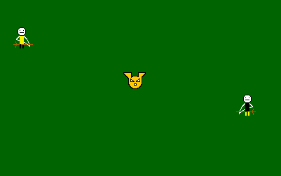  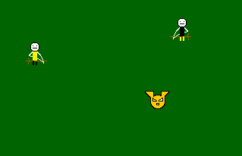 | Pass
6 | Every level should be harder than the last one by adding more walls or bludgers that would eliminate the player and end the game | Added more walls and bludgers on levels 3 to 5 with the bludgers eliminating seeker if they collide | Pass
7 | Snitch should start moving at level 5 | Snitch moves at level 5  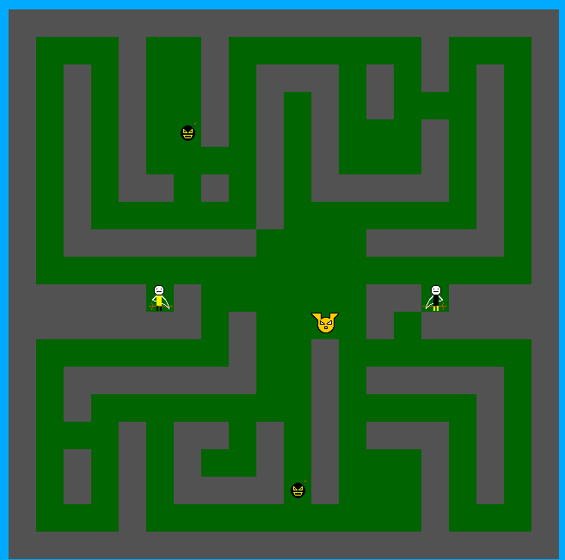  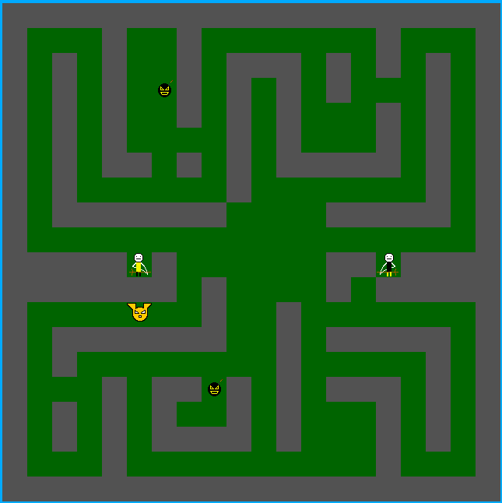 | Pass

8 | Seeker1 should move up when up arrow key is pressed | 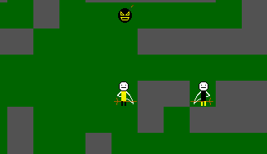  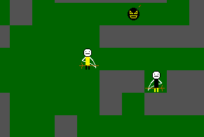 | Pass
9 | Seeker1 should move down when down arrow pressed | 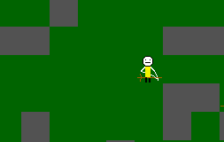  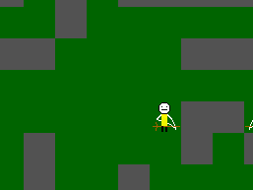 | Pass
10 | Seeker1 should move left when left arrow is pressed | 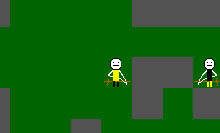  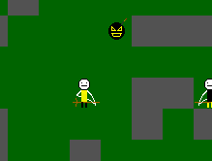 | Pass
11 | Seeker1 should move right when right arrow is pressed | 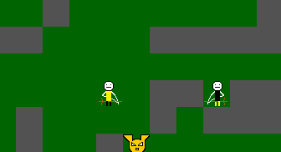  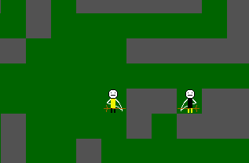 | Pass
12 | Seeker2 should move up when w is pressed |   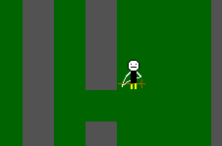 | Pass
13 | Seeker2 should move down when s is pressed | 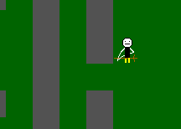  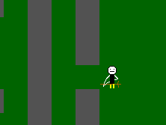 | Pass
14 | Seeker2 should move left when a is pressed | 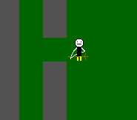  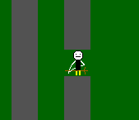 | Pass
15 | Seeker 2 should move right when d is pressed | 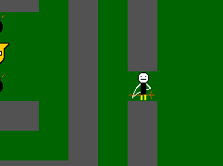  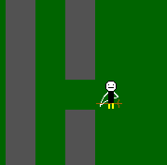 | Pass
16 | Map should appear when then the game starts | 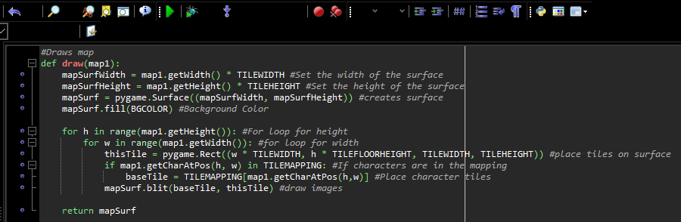  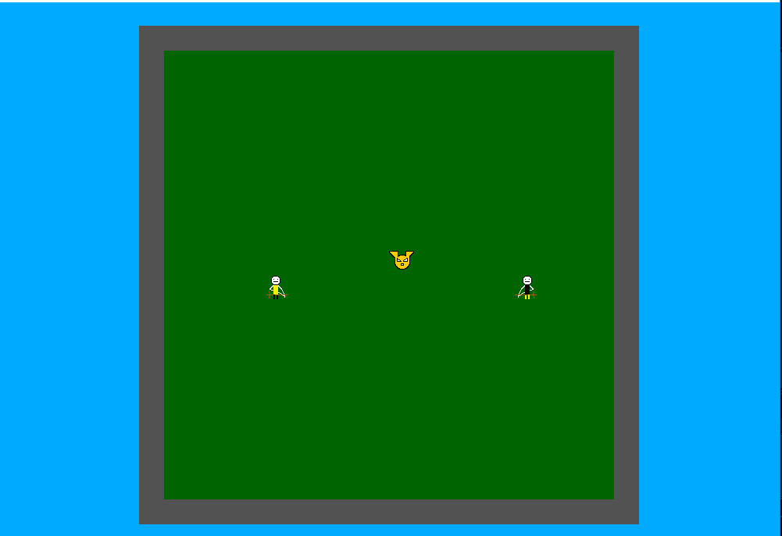 | Pass
17 | Seeker1 should collide with wall | 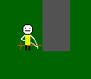 | Pass
18 | Seeker1 should collide with seeker2 | 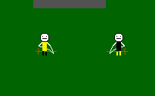  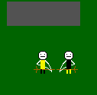 | Pass
19 | Seeker1 should Collide with Bludger |    | Pass
20 | Seeker2 should collide with wall |   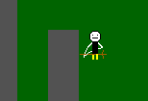 | Pass
21 | Game should record seeker 2 movement | 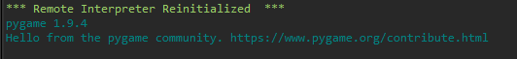  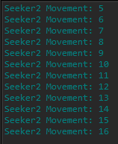 | Pass
22 | Seeker2 should Collide with Bludger |    | Pass
23 | Seeker2 should be able to catch the snitch | 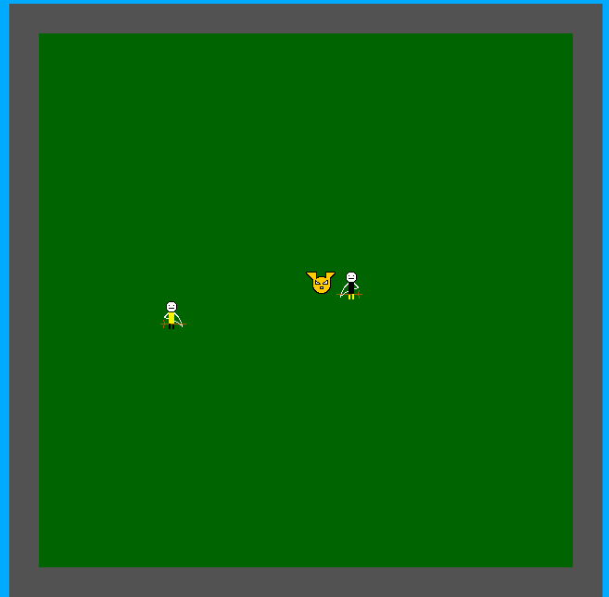  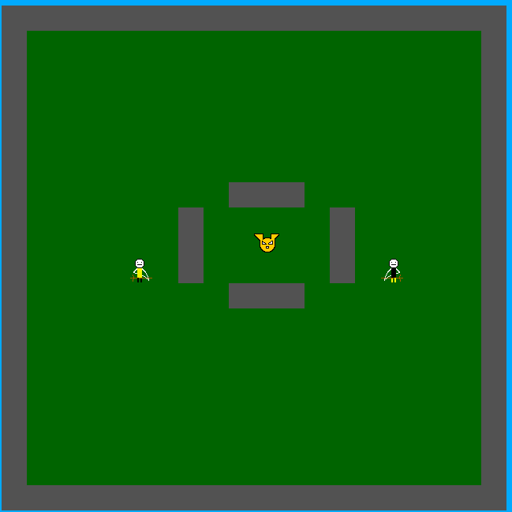 | Pass
24 | Game should show results when it finishes and display the winner | 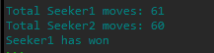 | Pass
25 | Game should give seeker1 and seeker2 1 score every time they catch a snitch |  | Pass

